### 

Installing Terraform

What is Terraform?

How do I start using Terraform?

Where Are Configs Stored?

Terraform Blocks Broken Down

Terraform

Provider

Resource

Data

Output

Module

Variable

Locals

Sample codes

Create S3 buckets

Create 2 EC2 instances

Create AWS DynamoDB table

Additional Challenges

Importing resources from AWS Console to Terraform

Using Terraform functions

Managing multiple environments using Terraform Workspaces

Overview

What is Terraform workspaces?

Further tutorials

### Configure aws access key:

### Install aws cli on your terminal $ sudo snap install aws-cli --classic # version 1.15.58

### Goto aws console create access key

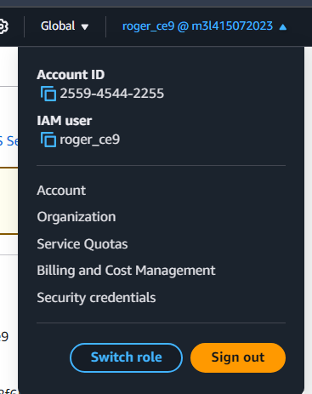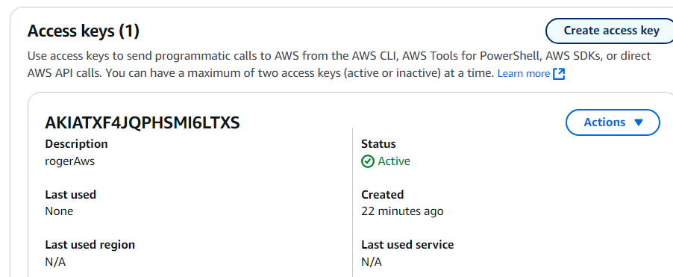

Can download csv version of the access key and secret key pair to copy paste aws credential config later.

1. On your terminal,   
   $ aws configure  
   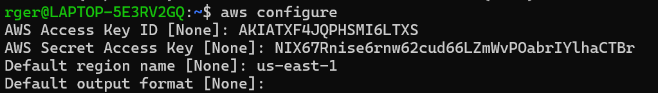
2. Confirm credentials in your terminal,  
   $ cat ~/.aws/credentials

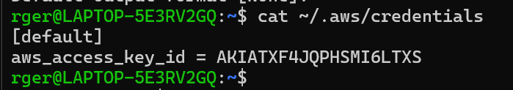

## Installing Terraform

<https://developer.hashicorp.com/terraform/tutorials/aws-get-started/install-cli>

## What is Terraform?

Terraform is an open-source infrastructure as code (IaC) tool developed by HashiCorp. It allows you to define, provision, and manage infrastructure resources such as virtual machines, networks, storage, and other cloud-based services in a declarative way. Terraform uses a configuration language called HashiCorp Configuration Language (HCL) or JSON to describe the desired state of your infrastructure.

With Terraform, you can define your infrastructure as code, version it, and apply changes in a consistent and repeatable way. Terraform supports multiple cloud platforms such as Amazon Web Services, Microsoft Azure, Google Cloud Platform, and many others, making it possible to manage infrastructure across multiple clouds and on-premises environments.

Look at this link to see what kind of online resources you can build with Terraform:

<https://registry.terraform.io/browse/providers>

## How do I start using Terraform?

<https://developer.hashicorp.com/terraform/tutorials/aws-get-started>

<https://registry.terraform.io/providers/hashicorp/aws/latest/docs>

We need to run terraform in the following steps:

1. **Initialize** - We need to initialize our Terraform environment by running the terraform init command. This allows you to download the necessary providers and modules that you have specified in your configuration.
2. **Plan** - After initializing the Terraform environment, we can create an execution plan with the terraform plan command. This plan shows us what changes Terraform will make to our infrastructure.
3. **Apply** - After we have reviewed the execution plan from the previous step and are satisfied with the proposed changes, we can apply the changes proposed by running the terraform apply command. Terraform will make the necessary changes to our infrastructure based on the plan.
4. **Destroy** - When we don’t need our cloud resources anymore, we can use the terraform destroy command to tear down all the resources created by Terraform.

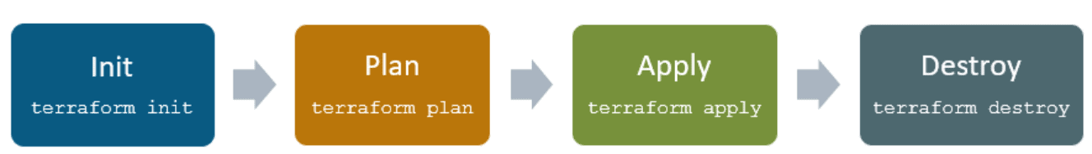

## Where Are Configs Stored?

Terraform state files store information about the infrastructure resources you manage using Terraform. They keep track of the actual resources created in your cloud provider environment, as well as the mapping between your configuration and those resources. This state is used to plan and manage updates to your infrastructure.

This file is normally named **\*.tfstate** e.g. **terraform.tfstate**

By default, Terraform stores state files locally in the same directory as your configuration files. However, this approach has limitations, especially in team environments or when working across multiple machines. To address these limitations, it's recommended to use remote state backends, which are external storage solutions for your Terraform state.

Here are some common remote state backends, and they can be particularly useful when working with Terraform in production or team settings:

* Amazon S3 and DynamoDB: AWS offers a remote state backend using Amazon S3 for storing the state file and Amazon DynamoDB for locking to prevent concurrent modifications. This is a popular choice when working with AWS resources. You can configure Terraform to use these services to store and manage your state.
* Azure Storage: If you're using Microsoft Azure, you can use Azure Storage as a remote state backend.
* Google Cloud Storage: For Google Cloud users, Google Cloud Storage can serve as a remote state backend.
* HashiCorp Consul: Consul is a service discovery and key-value store tool provided by HashiCorp. It can also be used as a remote state backend.
* Terraform Cloud: HashiCorp offers Terraform Cloud, a fully managed service that includes features like remote state storage, collaboration tools, and more. This is a convenient option for teams.
* Version Control Systems: While not a traditional backend, some teams opt to store their state files in version control systems (like Git) to maintain a history of changes. However, this approach might not offer the same level of state locking and management features as dedicated remote state backends.

To configure a remote state backend in your Terraform configuration, you need to modify your backend block in the configuration files. This configuration specifies the backend type (like "s3" for Amazon S3) and the necessary connection information.

Using remote state backends helps with better collaboration, state locking, and handling infrastructure as code at scale. It also provides a level of security by preventing sensitive infrastructure details from being stored in plain text on local systems.

Link: <https://developer.hashicorp.com/terraform/language/settings/backends/configuration>

## 

## Terraform Blocks Broken Down

### Terraform

The “terraform” block is used to specify settings for the Terraform execution environment, such as the required Terraform version and any backend configuration settings.

Example:

| terraform {  required_providers {  aws = {  source = "hashicorp/aws"  version = "~> 5.0"  }  } } |
| --- |

### 

### Provider

A provider block specifies the details of the provider being used. The provider is responsible for creating and managing resources in a specific infrastructure. The provider block is required for every Terraform configuration file.

Example:

| provider "aws" {  region = "us-east-1" } |
| --- |

If you do not specify your access_key and secret_key, terraform will use your AWS credentials

### Resource

A resource block specifies a single resource to be managed by Terraform. It includes the resource type, name, and its configuration options.

Example:

| resource "aws_instance" "example" {  ami = "ami-0c55b159cbfafe1f0"  instance_type = "t2.micro" } |
| --- |

### Data

A data block defines data sources that can be queried from an external system, such as a cloud provider or a database.

Example:

| data "aws_ami" "ubuntu" {  most_recent = true  filter {  name = "name"  values = ["ubuntu/images/*ubuntu-xenial-16.04-amd64-server-*"]  } } |
| --- |

### Output

An output block defines the values that Terraform should output after applying a configuration. Outputs are useful for retrieving information from Terraform to use in other parts of your infrastructure.

Example:

| output "public_ip" {  value = aws_instance.example.public_ip } |
| --- |

### Module

A module block specifies a reusable set of resources and configurations. Modules can be used to organize and reuse code across multiple Terraform configurations.

Example:

| module "vpc" {  source = "terraform-aws-modules/vpc/aws"  version = "3.0.0"  name = "my-vpc"  cidr = "10.0.0.0/16"  azs = ["us-west-2a", "us-west-2b", "us-west-2c"] } |
| --- |

Link: <https://registry.terraform.io/browse/modules>

### Variable

A variable block defines variables that can be used in a Terraform configuration. Variables are used to provide values that may change depending on the environment.

Example:

| variable "aws_region" {  type = string  default = "us-west-2" } |
| --- |

### Locals

The locals block defines local values that can be used within a Terraform module or configuration file. These values are computed once during Terraform execution and can be used to simplify complex expressions or provide more descriptive names for values.

Example:

| locals {  instance_count = length(var.instance_types)  instance_names = [ "web-${count.index}" for count.index in range(local.instance_count) ] } |
| --- |

## Sample codes

### Create S3 buckets

<https://registry.terraform.io/providers/hashicorp/aws/latest/docs/resources/s3_bucket>

| terraform {  required_providers {  aws = {  source = "hashicorp/aws"  version = "~> 4.0"  }  }  backend "s3" {  bucket = "sctp-ce7-tfstate"  key = "terraform-ex-ec2-luqman.tfstate" # Replace the value of key to <your suggested name>.tfstate for example terraform-ex-ec2-<NAME>.tfstate  region = "us-east-1"  }  }  # Configure the AWS Provider provider "aws" {  region = "us-east-1" }  # Create AWS S3 resource "aws_s3_bucket" "bucket" {  bucket = "my-tf-test-bucket" # Change to a globally unique name   tags = {  Name = "<Name> Bucket" # Change to your own name  Environment = "Dev"  } } |
| --- |

### Create 2 EC2 instances

<https://registry.terraform.io/providers/hashicorp/aws/latest/docs/resources/instance>

| provider "aws" {  region = "us-east-1"  # Edit below  access_key = "my-access-key"  secret_key = "my-secret-key" }  resource "aws_instance" "instances" {  ami = "ami-0b72821e2f351e396"  instance_type = "t2.micro"  key_name = "luqman-useast1-13072024" # change to your own keypair name  subnet_id = "subnet-09acf5721004f526c" # change to your own vpc subnet id  associate_public_ip_address = true  vpc_security_group_ids = [aws_security_group.ec2_sg.id]  count = 2  tags = {  Name = "luqman-webserver-terraform-${count.index + 1}"  }  } |
| --- |
|  |

### Create AWS DynamoDB table

<https://registry.terraform.io/providers/hashicorp/aws/latest/docs/resources/dynamodb_table>

| provider "aws" {  region = "us-east-1"  # Edit below  access_key = "my-access-key"  secret_key = "my-secret-key" }  resource "aws_dynamodb_table" "personal_table" {  name = "<NAME>_table"  billing_mode = "PAY_PER_REQUEST"  hash_key = "id"  range_key = "name"  attribute {  name = "id"  type = "S"  }  attribute {  name = "name"  type = "S"  } } |
| --- |

## Additional Challenges

### Importing resources from AWS Console to Terraform

### Using Terraform functions

You can use Terraform’s functions API to run a series of methods, ranging from numeric operations to file system operations. Take a look at this link to find out what built-in libraries are present:  
<https://developer.hashicorp.com/terraform/language/functions>

### Managing multiple environments using Terraform Workspaces

Refer to: <https://github.com/luqmannnn/terraform-multi-env>

#### Overview

There would be times when you need to manage multiple environments (dev, uat, prod etc.) from the same terraform code repository. Instead of using a git branching strategy to manage the different environments (1 tfstate file per branch), you can also use terraform workspaces

#### What are Terraform workspaces?

Workspaces in Terraform are simply independently managed state files. A workspace contains everything that Terraform needs to manage a given collection of infrastructure, and separate Workspaces function like completely separate working directories. We can manage multiple environments with Workspaces.

Deletion/ destruction of one workspace will not impact the resources on another.

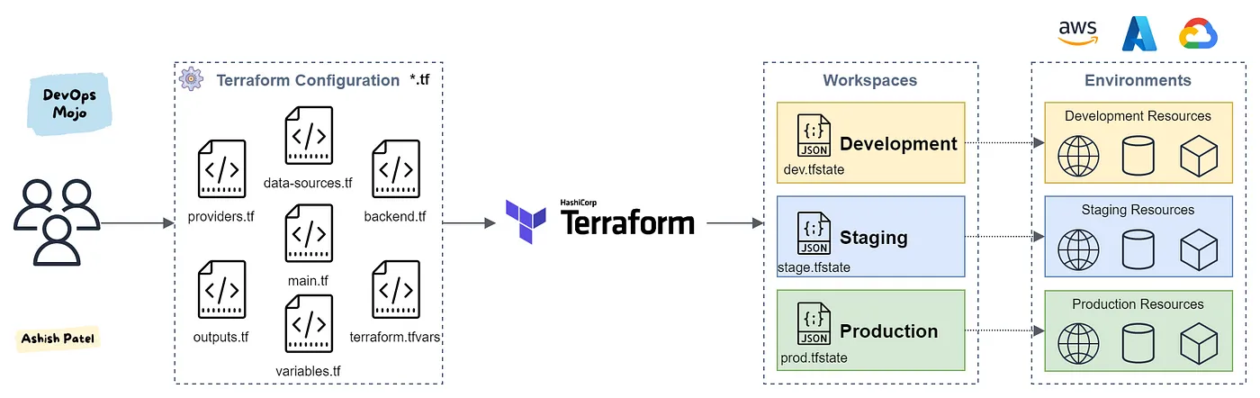

Refer to the github link above to start exploring this concept.

### Further tutorials

Follow the link to do more hands-on tutorial by the official Terraform page - <https://developer.hashicorp.com/tutorials/library?product=terraform>